**DAILY ONLINE ACTIVITIES SUMMARY**

|  |  |  |  |  |  |  |  |  |
| --- | --- | --- | --- | --- | --- | --- | --- | --- |
| **Date:** | **06/06/2020** | | | | | **Name:** | **Varshitha Makam** | |
| **Sem & Sec** | **8th B** | | | | | **USN:** | **4AL16CS118** | |
| **Online Test Summary** | | | | | | | | |
| **Subject** | | **IOT** | | | | | | |
| **Max. Marks** | | **30** | | **Score** | | | **29** | |
| **Certification Course Summary** | | | | | | | | |
| **Course** | **Robotics Process Automation** | | | | | | | |
| **Certificate Provider** | | | **GUVI** | | **Duration** | | | **3 hours** |
| **Coding Challenges** | | | | | | | | |
| **Problem Statement:** | | | | | | | | |
| **Status: Completed** | | | | | | | | |
| **Uploaded the report in Github** | | | | | **yes** | | | |
| **If yes Repository name** | | | | | **Varshithamakam**  **https://github.com/alvas-education-foundation/varshithamakam** | | | |
| **Uploaded the report in slack** | | | | | **yes** | | | |

Online Test Details:

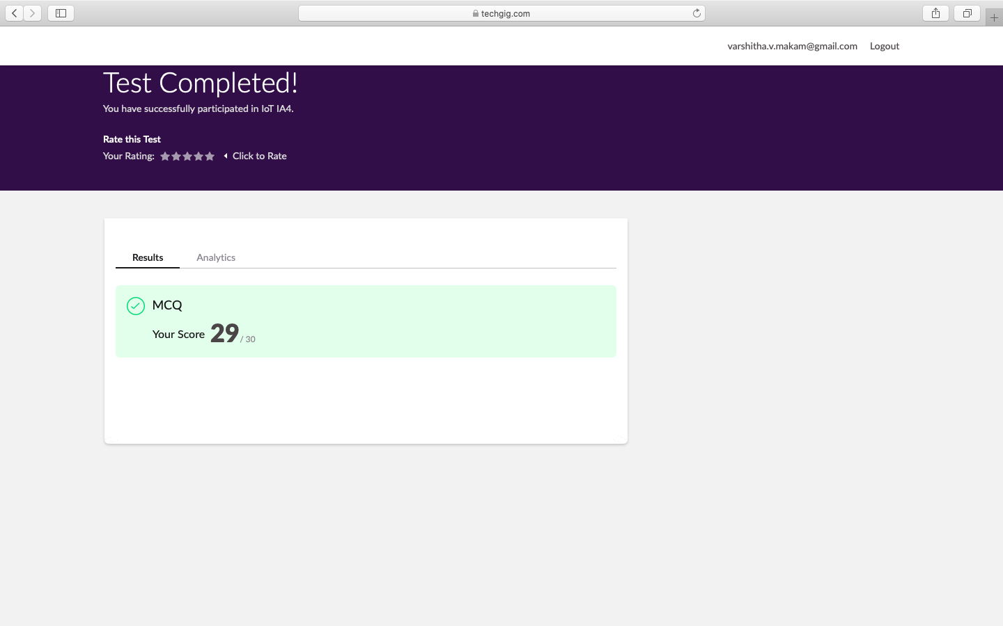

Certification Course Details:

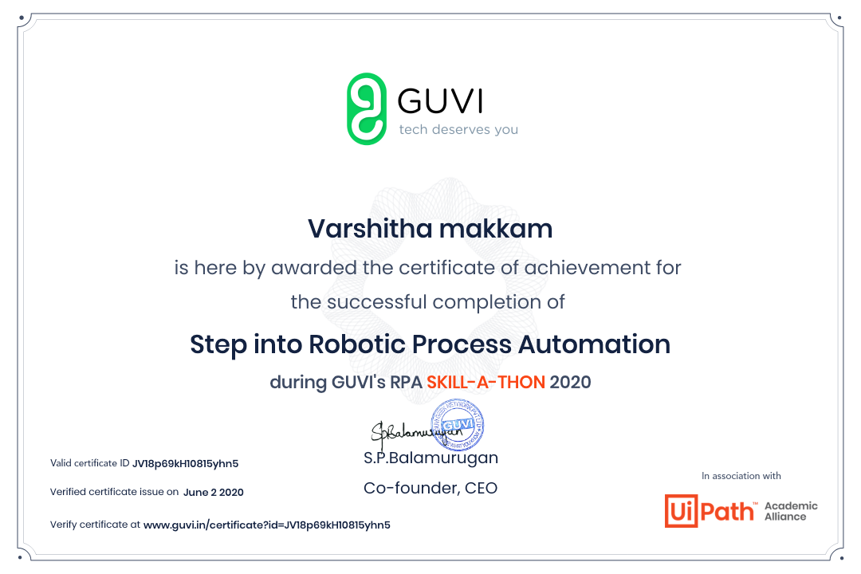

Coding Challenges Details:

(Attach the snapshot and briefly write the report

for the same)

time=float(input("Inputtimeinseconds:")

)

day=time

//(24*3600) time=time%(24*3600)

hour=time//3600

time%=3600

minutes=time

//60 time%=60

seconds=time print("day:->%d"%(day))

print("hour:->%d"%(hour))

print("minutes:->%d"%(minutes))

print("seconds:->%d"%(seconds))